Maya Project Proposal: Old Western Town

## 42859581

# Personal Motivation

I’m required to do this project in order to pass the unit. Thankfully though, I find Westerns and the Old West interesting, and enjoy watching Westerns and playing games using the West as a setting. Western towns have a very iconic look, and a certain feel when walking around them that I like.

# Research on Western Towns

Some examples of sources include:

<http://en.wikipedia.org/wiki/American_frontier>

<http://www.ghosttowngallery.com/>

<https://www.youtube.com/watch?v=ZWXuR6ta18A>

Google Image search for ‘Wild West Towns’

<https://www.youtube.com/watch?v=YEBzZAteaM4>

<https://www.youtube.com/watch?v=5tk7I8bK498>

# Research findings

Buildings in Western towns are very angular, usually consisting of a main rectangular block with some adornments like a shelter, balcony or sign. The buildings are wooden, mainly coloured brown, red or grey. In a town the buildings are usually all lined up either side of a road with little to no space between them. They all have doors at the front so you can enter straight off the path. Most buildings have a large sign attached that says what kind of building it is (e.g. Bank, General Goods, Undertaker). A Western town is situated in a dry, desert area, surrounded by plains and sometimes mountains.

# Final Project

I will be making 5 buildings in order to meet the Credit level. I will be making the following buildings, with pictures that look similar to my plan.

## A Saloon

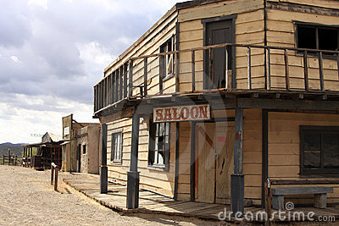

## A Church

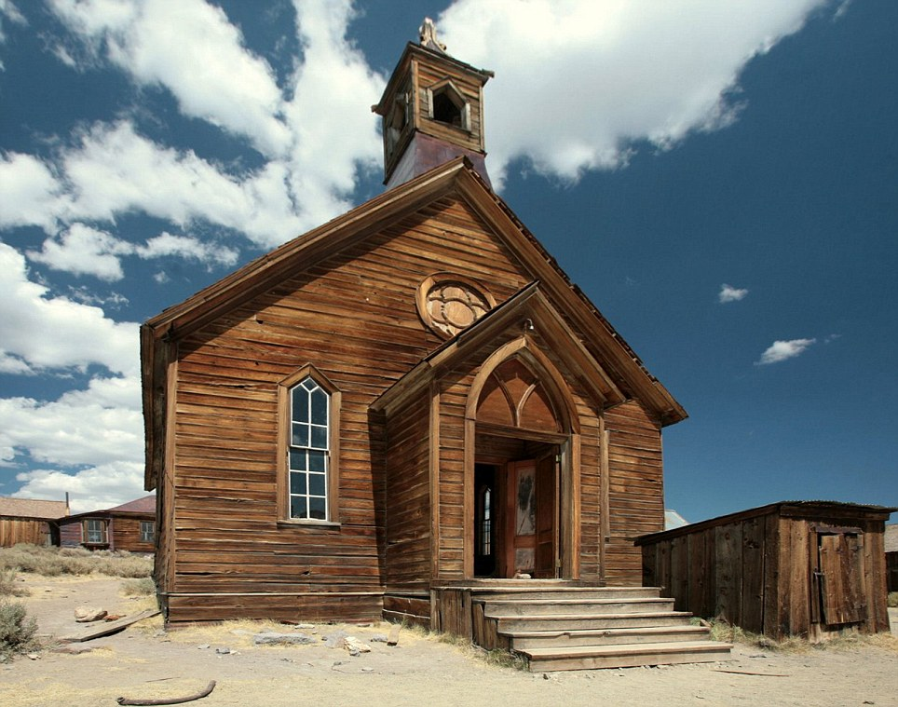

## Gallows:

(not strictly a building but it is a structure that would require a reasonable amount of work)

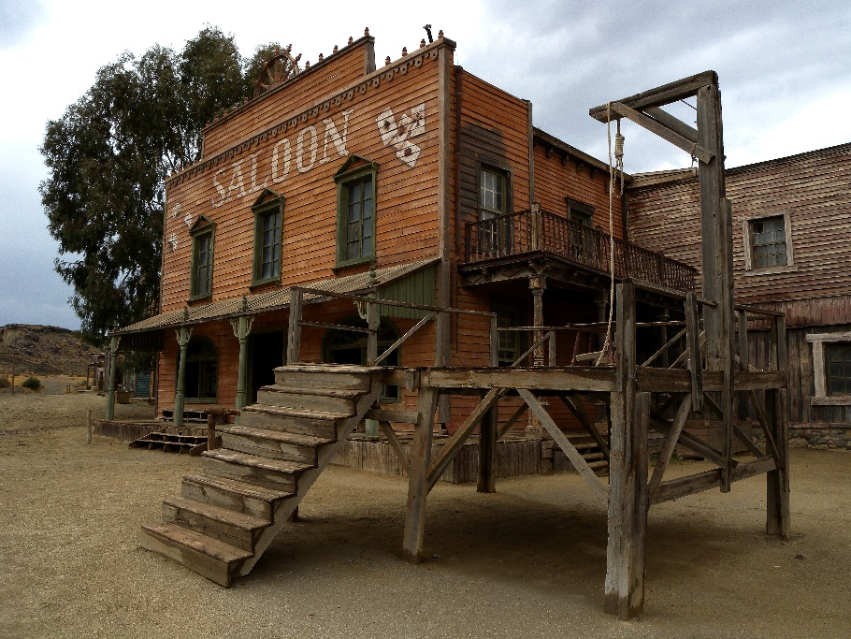

## And a Bank and General Goods Store:

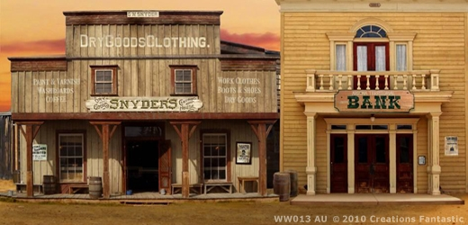

Each building will only be an exterior, no interiors will be modelled.

# Tools To Be Used In Maya

Cube Tool, Create Polygon Tool, Cut Faces Tool, Extrude Tool, Texturing, Wedge Face Tool, Combine Tool, Curve Tools, Photoshop for textures

# Time Management

I’m expecting the project to take between 10-20 hours to complete.

# Potential problems with the project

The buildings seem to be simpler shapes than the shark, but as there is more of them it will take more time to do. I believe my skills are good enough to complete the buildings but time management may be slightly difficult. Trying to perfect the little details in each building will be difficult as well, especially if I have to make some sections separately and then combine them to the main shape (like signs). Texturing might also be an issue- with the shark I just used a single plain colour, whereas the buildings will require multiple, more detailed textures.